**EXPERIMENT NUMBER 1**

| Name of Student: Sangeet Agrawal | PRN: 21070122140 | Section: CS-B |
| --- | --- | --- |

**Title: Virtual Lab setup for network security**

**Aim:** Demonstrate setup of a virtual lab to work with multiple operating systems to perform various network security tasks.

**Objective:** To make students work with multiple operating systems simultaneously using virtualization.

**Theory:**

There are multiple cross-platform software available for virtualization like Oracle VM VirtualBox, VMWare fusion etc. This software helps the user to create a virtual environment to install multiple OS as virtual machines. The following steps will allow a Windows user to create a virtual machine using Oracle VirtualBox.

1. Visit the link below and download the appropriate software as per your system requirements. <https://www.oracle.com/in/virtualization/technologies/vm/downloads/virtualbox-downloads.html>
2. Double click on the downloaded executable file and follow the instructions. By default, installation will be performed in C drive. You can select any drive of your choice before continuing installation.
3. Download Kali Linux ISO file using link:

<https://www.kali.org/get-kali/#kali-platforms>

1. Select 64 bit installer image to download ISO file.
2. Start VirtualBox by double clicking on its icon.
3. Goto Machine -> New to create a virtual machine.
4. Give name for your VM - here for example KaliOS23
5. Select Kali ISO file downloaded in step 3 and click next.
6. You can keep RAM, CPU and HDD size to default or adjust as per your requirements.
7. Click next to complete attaching ISO image to VM.
8. Once done, start KaliOS23 created in step 7. This will open your dialog box of Kali Linux OS installation.
9. Follow the instructions and install Kali Linux like any other Linux flavour OS.

**Conclusion:** In this experiment, we set up a virtual lab using Oracle VM VirtualBox (In my case: UTM for Macs - Apple Silicone) and installed Kali Linux & Parrot Security. This taught us the importance of virtualization for network security tasks, enabling us to efficiently handle complex IT scenarios.

**Implementation question:**

1. Installation of virtual box

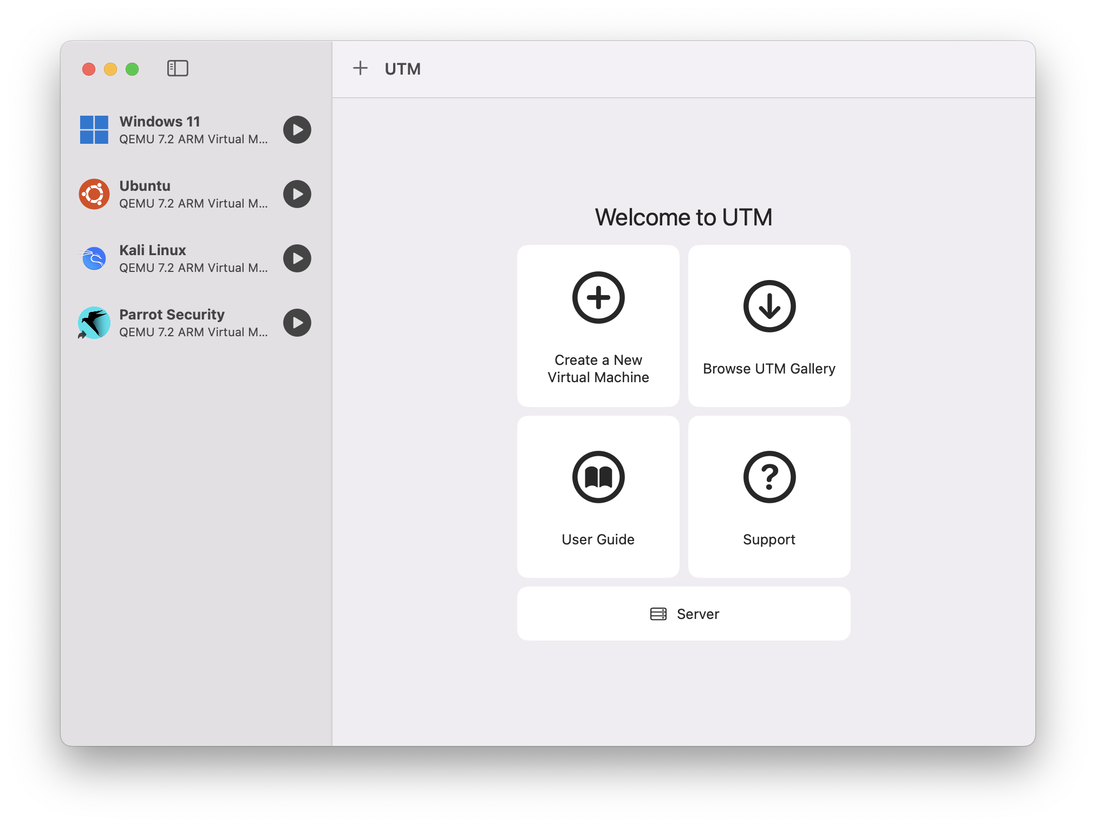

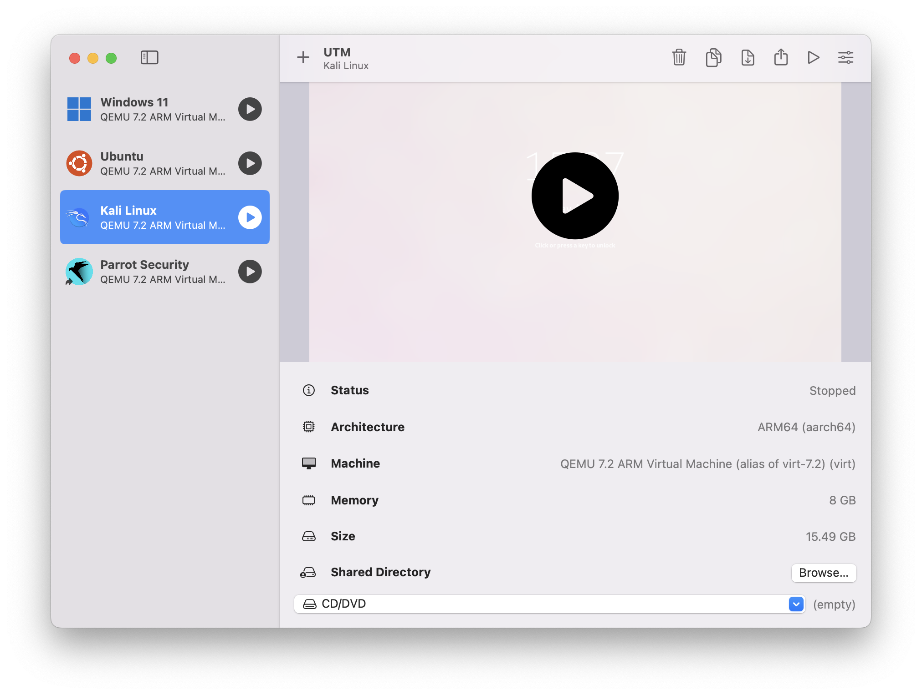

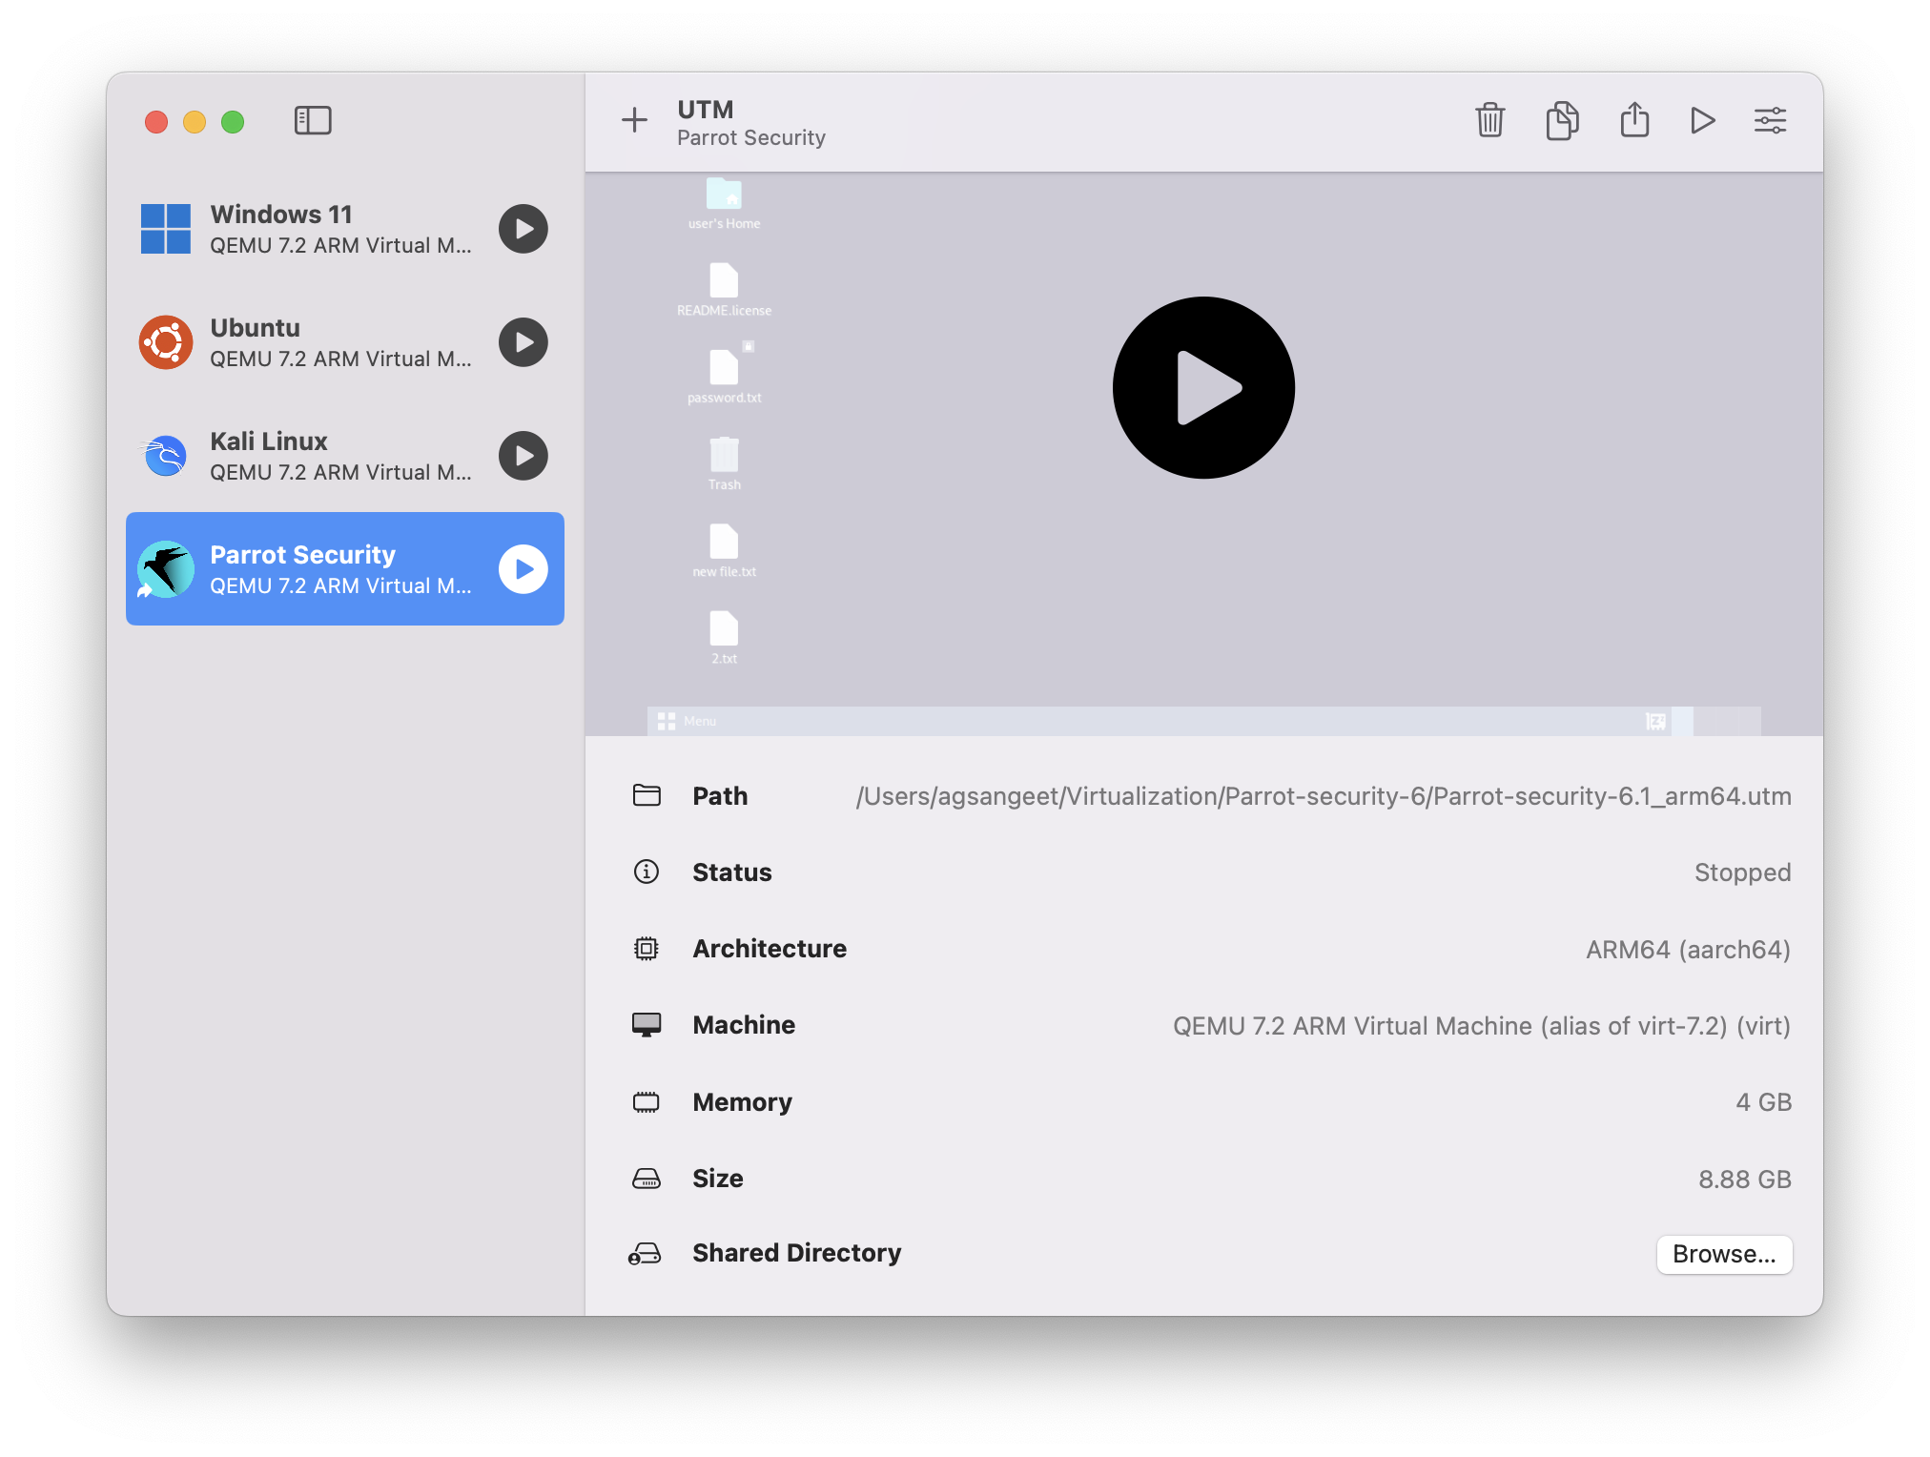

1. Installation of Kali or Parrot OS, any one Windows flavour OS

